

**SECOND SEMESTER SESSION 2023/2024 (A232)**

**STIW2044 MOBILE PROGRAMMING**

**ASSIGNMENT II**

**LECTURER NAME : DR. AHMAD SUKI CHE MOHAMED ARIF**

**CLASS GROUP : GROUP B**

**SUBMISSION DATE : 09 / 06 / 2024**

**GROUP MEMBERS**

|  | **NAME** | **MATRIC NUMBER** |
| --- | --- | --- |
| **1.** | **NURUL JANNAH BINTI MOHD SAUBRI @ MOHD SABRI** | **292104** |
| **2.** | **NURSYUHAIDA BINTI SAIPUL-HIZAM** | **291805** |
| **3.** | **SHARWIN A/L PARAMESWARAN** | **295026** |

**ASSIGNMENT REPORT**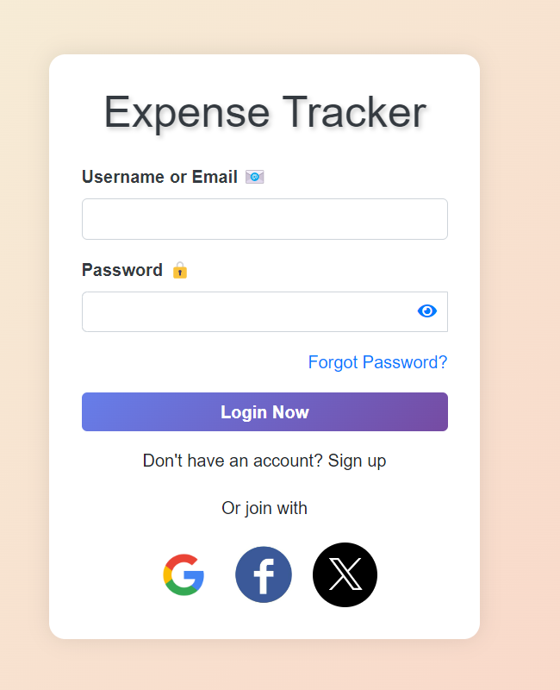

*Image 1.1 : Login Page*

Welcome to the Expenses App!

After downloading the .apk file and launching the app, you’ll be greeted by our user-friendly Login screen. New to the app? Simply sign up to get started. Returning user? Just log in and start managing your expenses with ease!

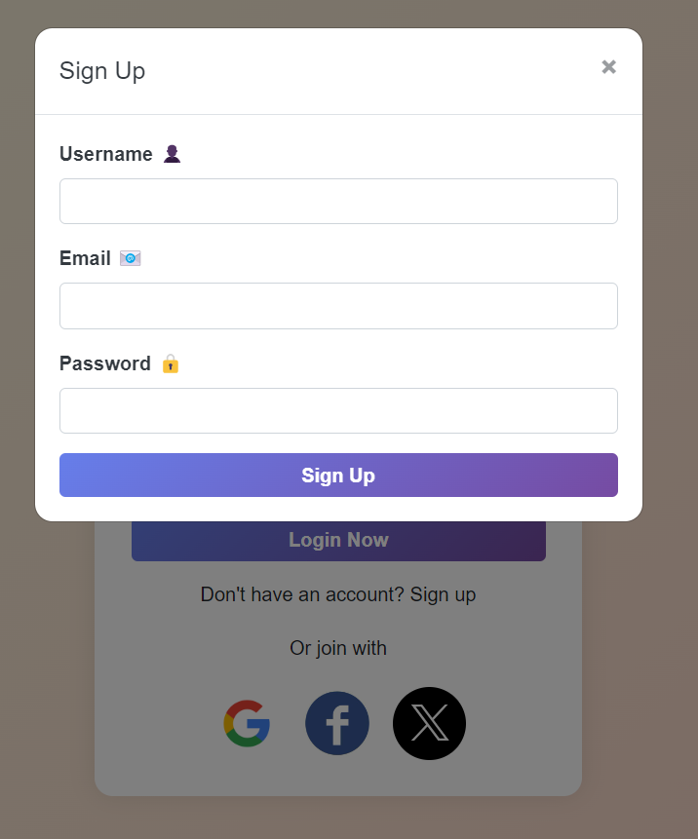

*Image 1.2 : Sign up pop-up window*

To get started, simply sign up by entering your Username, Email, and Password. Once you've filled in the details, click the "Sign Up" button, and your account will be created instantly!

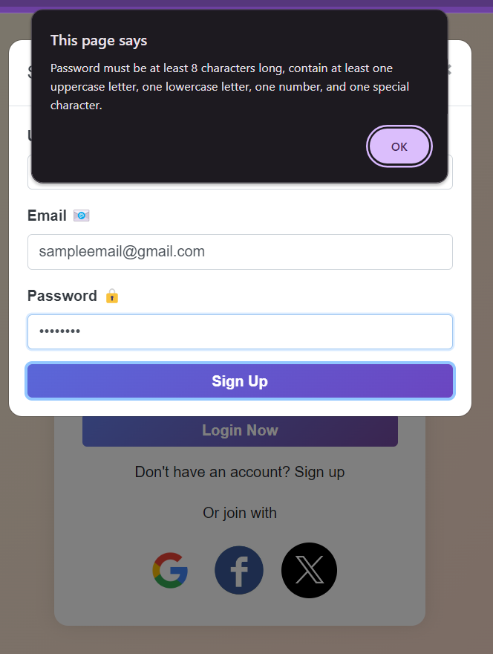

*Image 1.2.1 : Sign up failed Pop-up window*

Please note that your password must meet certain requirements to be valid. We recommend using special characters associated with numbers, such as !, @, #, and more, to create a strong and secure password.

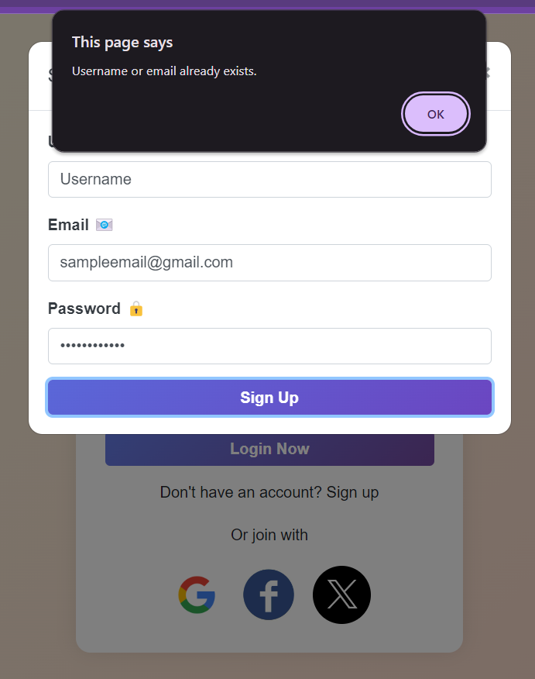

*Image 1.2.2 : Already existing email account*

Ensure that each email you use for signing up is unique. The system will reject any attempt to create a new account with an email address already associated with an existing user. This is crucial to maintain the integrity and security of our user database.

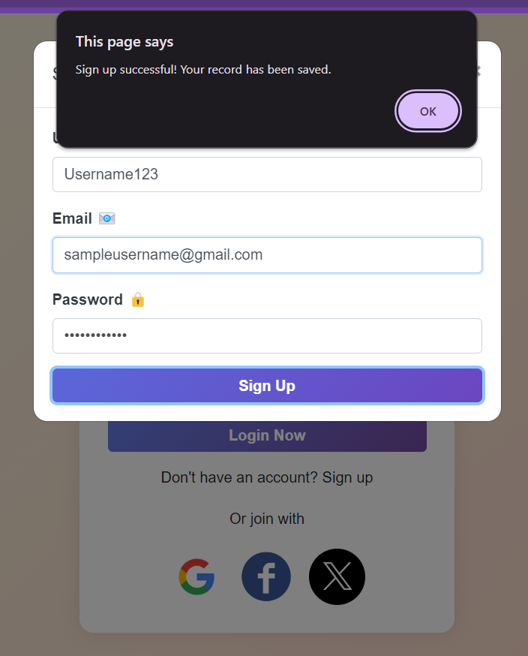

*Image 1.2.3 : Successful sign up*

After successfully completing the sign-up process, a pop-up window will confirm your account creation. You will then be redirected to the login page, where you can login and start using the Expenses App with your newly created account.

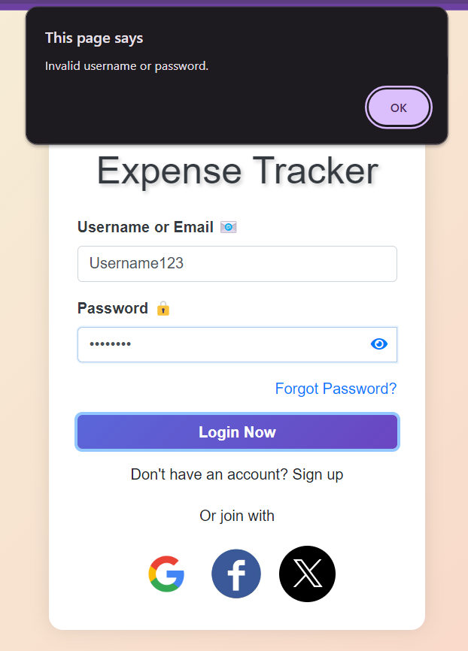

*Image 1.3 : Failure to login*

Remember to input the correct Username and Password, as incorrect entries will prevent access to the system!

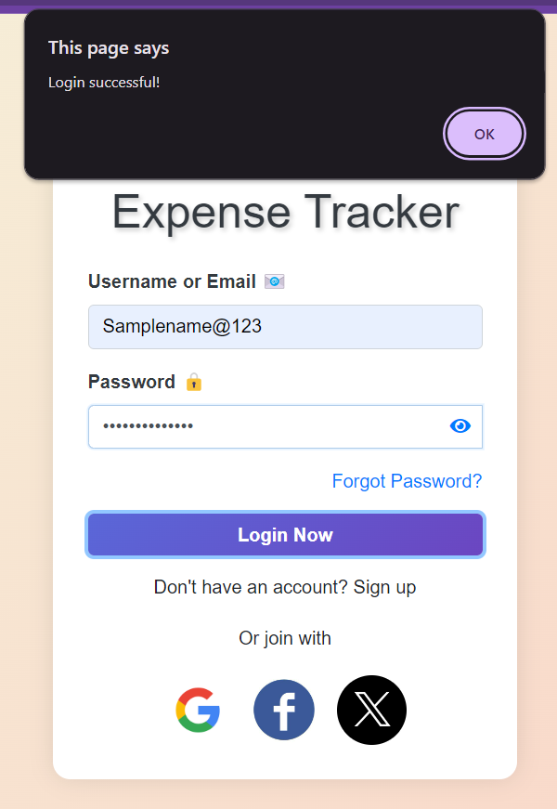

*Image 1.3.1 : Login Successful*

After entering the correct Username and Password, a pop-up window will confirm your successful login. You will then be directed to the app's homepage, where you can begin managing your expenses.

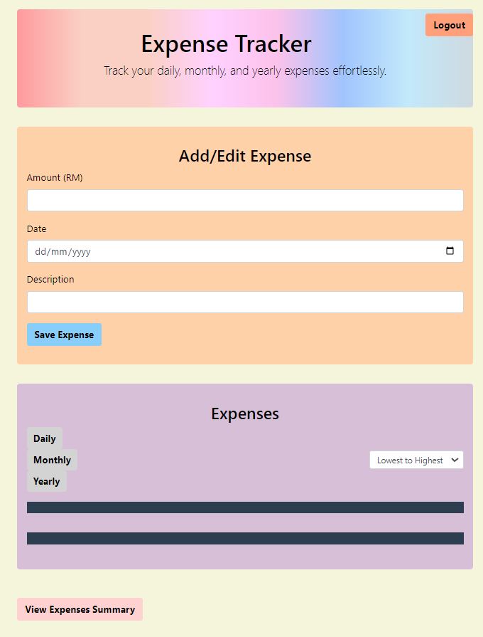

*Image 1.4 : Expenses App homepage*

Once logged in, you're ready to explore all the features of the Expenses App!

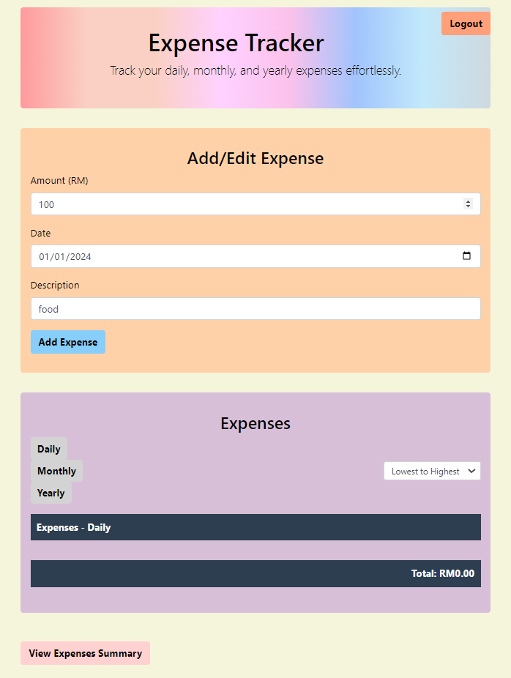

*Image 1.5 : Making an expense entry*

Once logged into the Expenses App, you can easily manage your expenses by following these steps:

1. **Insert Details:** Enter the amount, date, and description of your expense.
2. **Add Expense:** Click the “Add Expense” button to save the entry. Your expense will then be displayed in the “Expenses” column.

**Additional Features:**

* UpDown Button: Adjust your expense amount with ease.
* Calendar Icon: Select the exact date of your expense effortlessly.

These tools are designed to help you accurately record and manage your expenses with minimal hassle.

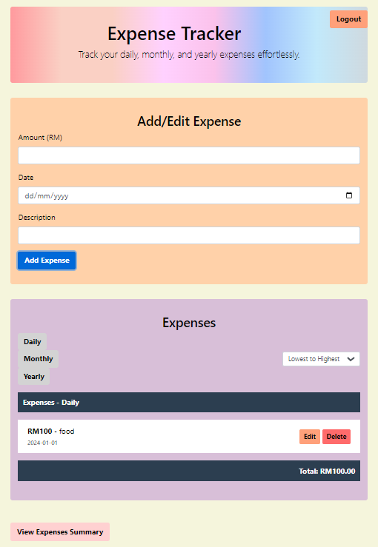

*Image 1.6 : Successful expense entry*

The expense entry has been successfully saved! From this point onward, you can explore our features, including:

* Edit and Delete Buttons: Modify or remove any expense entry with ease.
* "Lowest to Highest" Drop-Down Menu: Sort your expenses effortlessly.
* "View Summary" Button: Display the total amount of all entries along with a detailed chart.

Examples of these features are shown below. Enjoy managing your expenses with our intuitive tools!

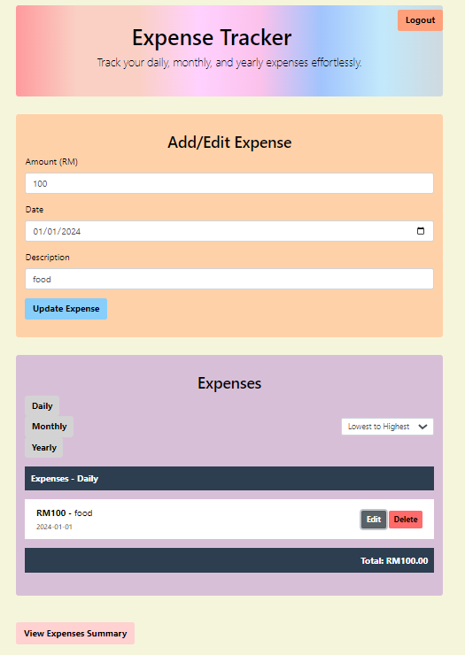

*Image 1.7 : Edit Expense*

When you click on the "Edit" button, the original entry will automatically populate. After making the necessary modifications, simply click on the "Update Expense" button to save the changes. The latest entry will then be displayed, ensuring your records are always up to date.

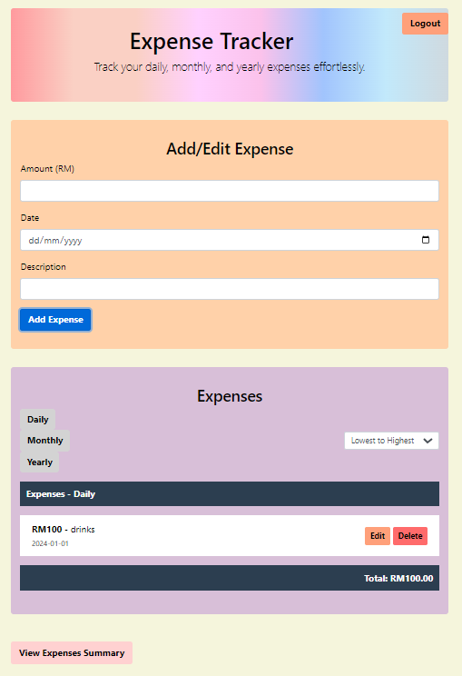

*Image 1.7.1 : Updated Expense*

This is the sample Edited expense after the entry has been updated by the user.

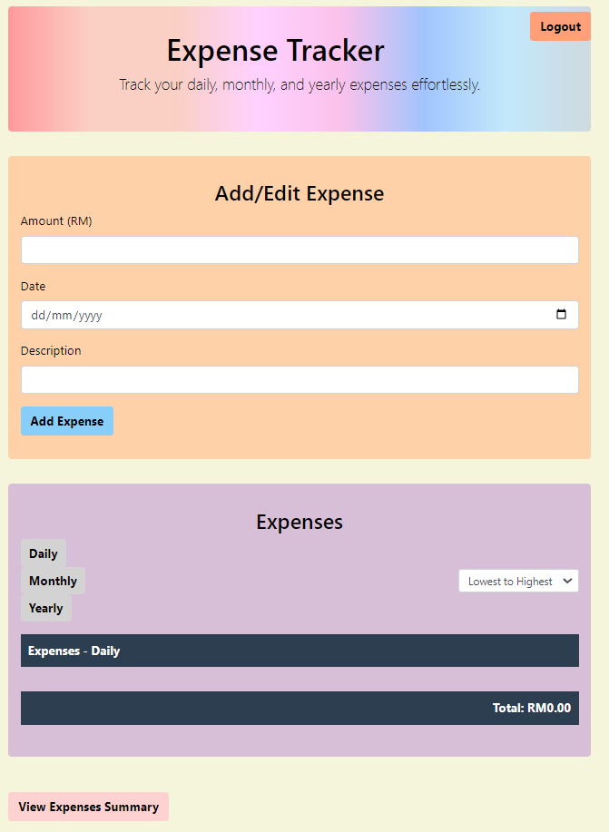

*Image 1.7.2 : Deleting entry*

Clicking on the “Delete” button would automatically remove the entry and update the list in real time.

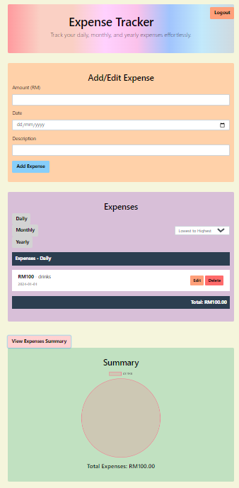

*Image 1.8 : View Expenses Summary column*

When you click on the "View Expenses Summary" button, a new column will open displaying the total expenses along with a visually informative pie chart. This feature provides a comprehensive overview of your spending, helping you better understand your financial habits at a glance.

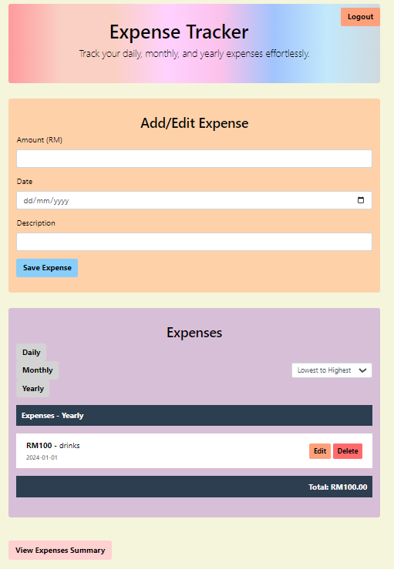

*Image 1.9 : Logout feature*

By clicking on the "Logout" button, you will be securely logged out of your account and redirected back to the original login page. This ensures the safety of your account and allows for easy access the next time you use the Expenses App.